SQL Assignment.

**Mystery:** A crime has taken place and the detective needs your help. The detective gave you the crime scene report, but you somehow lost it. You vaguely remember that the crime was a **murder​**that occurred sometime on Jan.15**, 2018​and** that it took place in SQL **City.** Start by retrieving the corresponding crime scene report from the police department’s database.

**Queries:**

1. SELECT *

FROM crime_scene_report

where date= 20180115

AND type="murder"

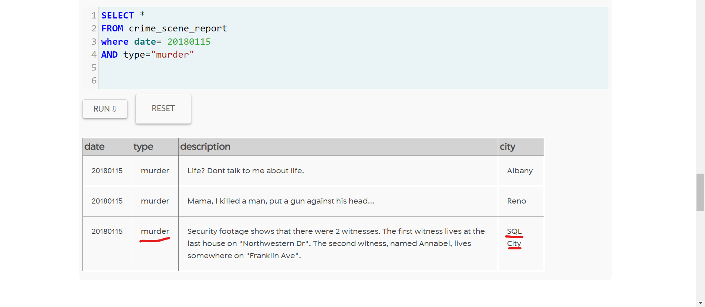

1. SELECT *

FROM person

where address_street_name

LIKE "Franklin Ave"

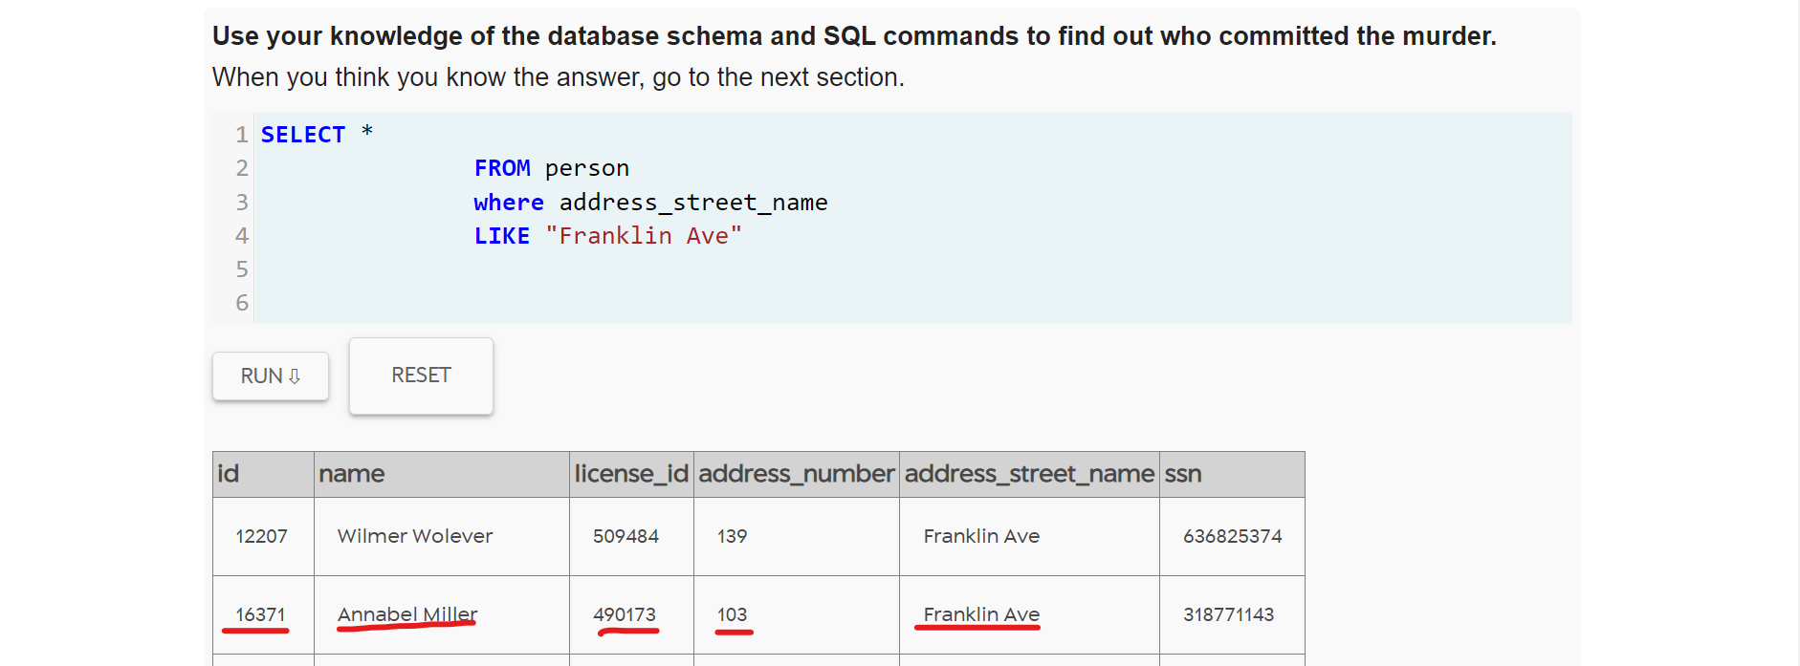

1. SELECT *

FROM person

where address_street_name

LIKE "Northwestern Dr"

Order by address_number DESC

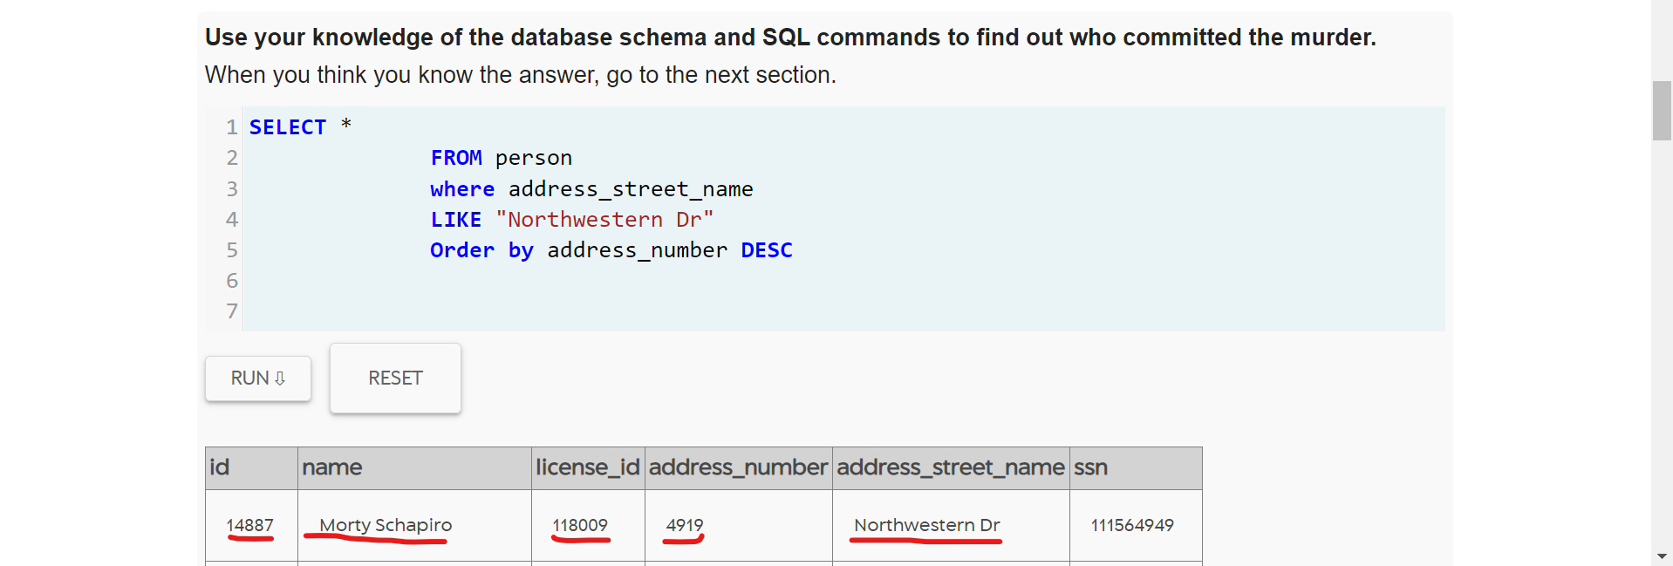

1. SELECT *

FROM interview

where person_id=16371

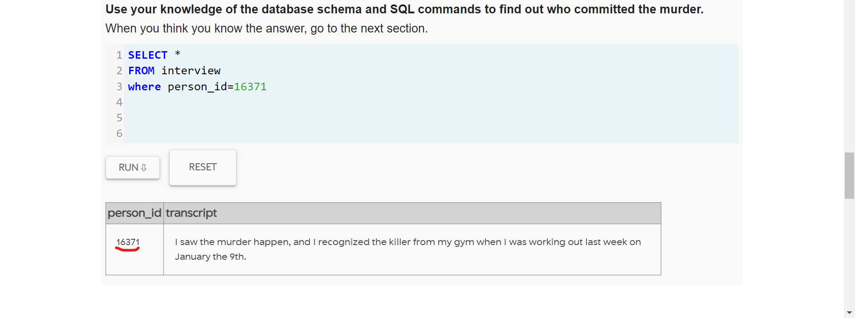

1. SELECT *

FROM interview

where person_id=14887

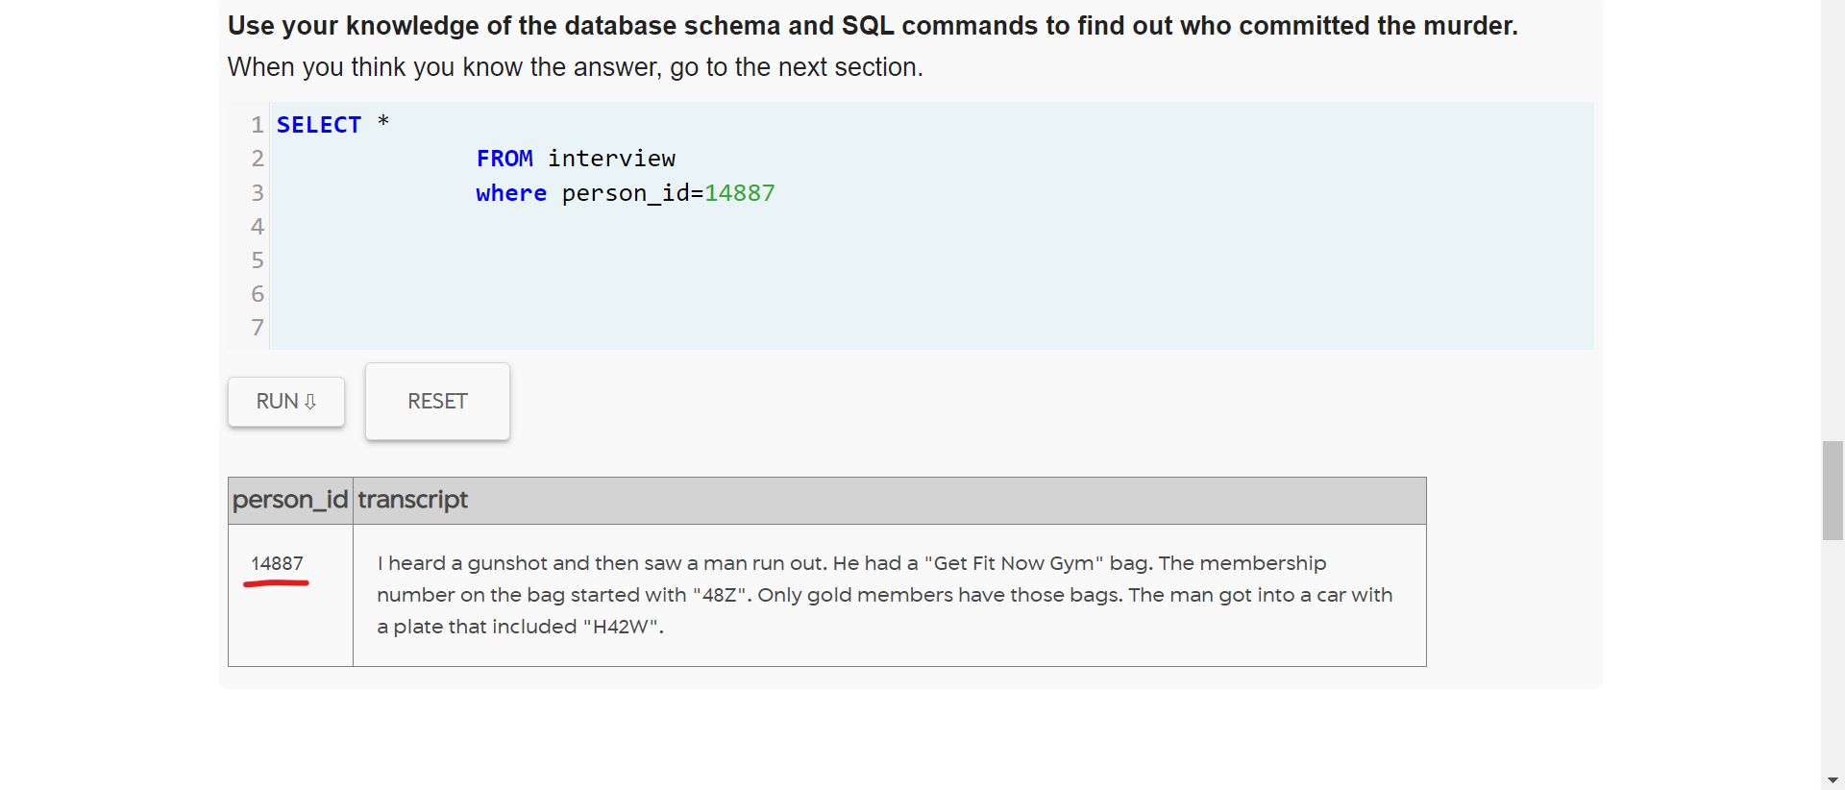

1. SELECT *

FROM get_fit_now_check_in

JOIN get_fit_now_member

ON get_fit_now_check_in.membership_id = get_fit_now_member.id

WHERE membership_id

LIKE "48Z%"

AND check_in_date=20180109

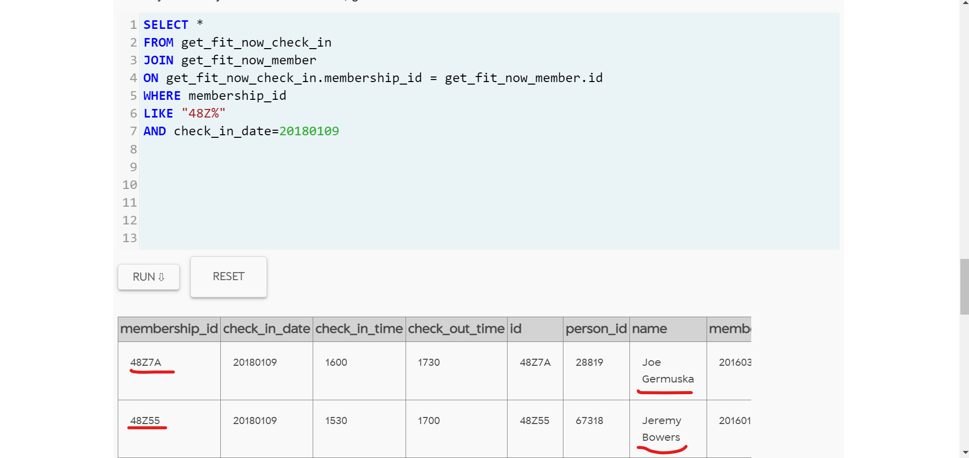

1. SOLVED MYSTERY

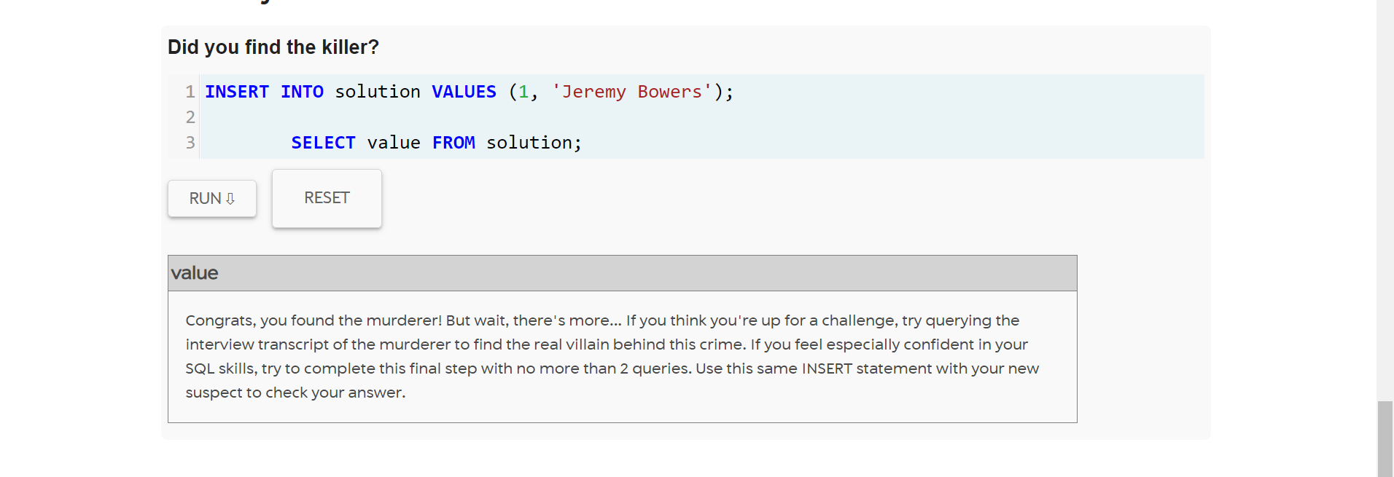

1. To find real killer

SELECT transcript

FROM interview

WHERE person_id = ‘67318’

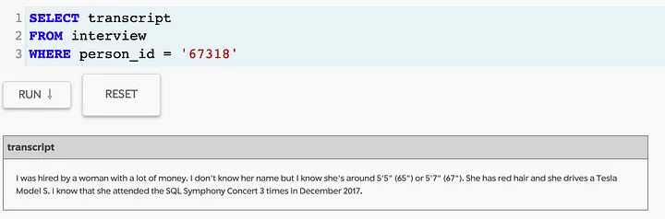

1. Interview transcript of Jeremy Bowers,

SELECT * FROM interview

WHERE person_id = ‘67318’



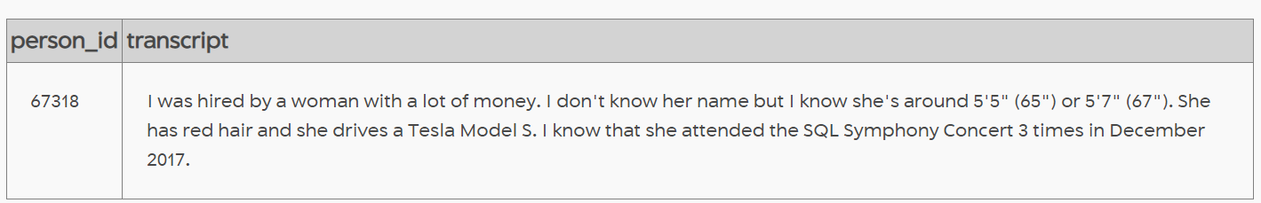

1. Finding the person as per Jeremy’s description,

SELECT *

FROM drivers_license

WHERE car_make = “Tesla” AND car_model = “Model S”

AND gender = “female” AND hair_color = “red”



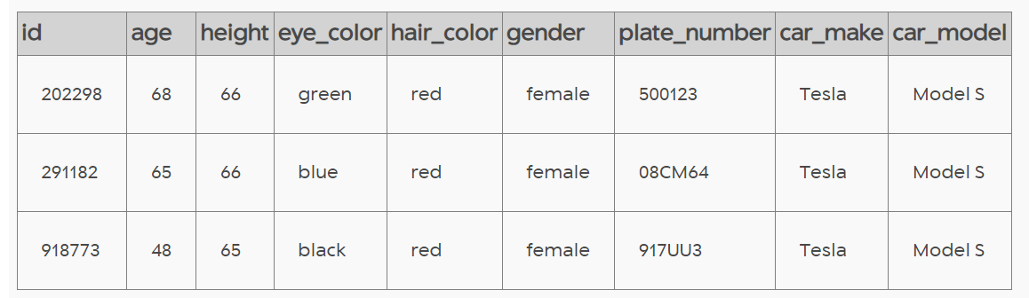

1. Figuring out the name

SELECT * FROM person

WHERE license_id = “202298” OR license_id = “291182” OR licencse_id = “918773”



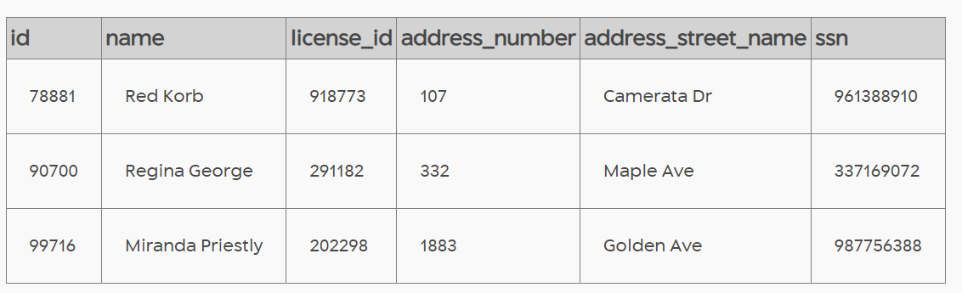

1. Figuring out which person also attended the symphony

SELECT person_id, count(*), event_name FROM facebook_event_checkin GROUP BY person_id

Having count(*) = 3 AND event_name = “SQL Symphony Concert” AND date like “%201712”



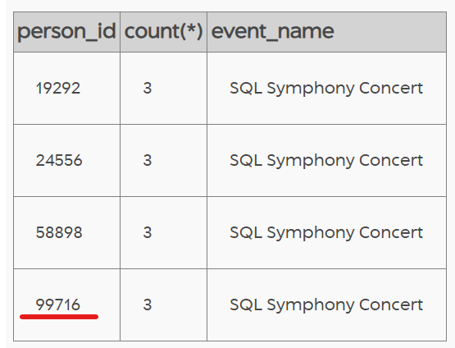

Thus, found the true mastermind behind the murder. It is Miranda Priestly.

1. Killer found

INSERT INTO solution VALUES (1, ‘Miranda Priestly’);

SELECT value FROM solution;

